**Increasing evapotranspiration results in decoupling of vegetation responses to warming in Tibetan Plateau**

Xue Dai, Zhongbo Yu*

**Abstract**

Plant growth often responds positively to warming in ambient temperature. Hence, most earth system models agree on continued future increases in vegtation cover due to elevated temperatures. However, using two satellite-derived proxies of vegetation cover during 1982-2020, we found the mid-vegetated alpline ecosystem in the Tibetan Plateau was significant degraded in the latest significantly–warmed 40 years. The observed temperature response curves of vegetation revealed that the positive vegetation–temperature relationships in the high- and low-vegetated areas were reversed in the mid-vegetated area. A structural equation modelling (SEM) detected a clear evidence in the degrading area that warmer temperature sitmulates evapotranspiration and increases water consumption of the ecosystem (warming to drought, *r∂* = 0.34), which in turn, significantly reduces soil water content (drought to water availability, *r∂* = −0.68), leading to reducing water availability and restraining of vegetation growth. This consequence of such warming influences was only detectable in the moderately vegetated area in the Tibetan Plateau, as plant transpiration here tends to response more sensitively to water availability changes (compared to the highly-vegetated areas) and accounts for a larger proportion of the total water consumption (compared to the low-vegetated area). These findings emphasize the risk of vegetation degradation in mid-vegetated areas under elevated temperatures in the Tibetan Plateau, and highlight the central role of plant transpiration in regulating the intensity water availability stress on vegetation prediction under elevated temperatures.

**Introduction**

Previous in situ studies have documented a strong positive relationship between vegetation cover and growing season temperature1-3. This relationship can be interpreted as an increase in photosynthesis in response to warmer climate conditions through many ways such as photosynthesis-related biochemical processes (such as enzymatic reaction rates) and photosynthesis-related biophysical processes (such as CO2 and water exchange between the leaf and the atmospheric)4-6. It is one of the most accepted hypotheses in the field of ecology that higher temperature during the growing season promotes plant growth. This hypothesis has been directly incorporated into various terrestrial ecosystem models that have variants to account for acclimation, that is, a temporal adjustment of optimum photosynthetic temperature to air temperature during growth2,7,8. Several vegetation studies have further validated this hypothesis with remote sensing techniques and have observed significant greening tendencies of terrestrial ecosystems, especially in the northern high latitudes9,10. Some studies partly attribute these changes to variations in the atmospheric composition, such as CO2 fertilization effect11,12 , nitrogen deposition13,14, aerosol increase,15 or ozone hole10, and intensified human land management, such as afforestation in China and intensive farming in India13,16-18. However, global warming or increase in temperature is one of the main reasons for the rejuvenation of terrestrial vegetation10,19–21

As a consequence of obtaining a positive relationship between temperature and vegetation, most ecosystem models predict that ecosystems will continue to accumulate vegetation in a warmer world11,22. However, some regional case studies have recently found a divergence (or decoupling) in the relationship between vegetation growth and warming6,23-25. For example, D’Arrigo et al.26 reported a decline in the temperature sensitivity of tree growth, based on the tree-ring time series, during late twentieth century. Sanders-DeMott et al.27 revealed that the strength (correlation) of linkage between vegetation productivity and the temperature has declined from the early 1980s to 2011 in the northern hemisphere. Some studies even found non-linear relationships (similar to Gaussian relationships) between vegetation and temperature, implying that plant productivity increases with temperature up to a certain extent and decreases thereafter28,29. These divergence or decoupling phenomena suggest that the hypothesis of positive linear relationship between vegetation and temperature may overestimate the response of vegetation to climate warming, and even draw wrong predictions for some degraded or browning areas.

The underlying mechanism of this divergence or decoupling response is unclear10. One classic hypothesis suggests that plant response to temperature rise is only sensitive for a short time, and with the improvement of the adaptability of plants to temperature rise, their sensitivity to temperature rise will also decrease30,31. The resource limitation hypothesis proposes that the divergence or decoupling response of vegetation to warming depends on the interaction of multiple environmental resources and the response-ability of plants decreases with the consumption of resources5,32-34. As water is one of the most important resources for plant growth, some studies have tried to explain the divergence problems from the aspects of water transport mechanism of photosynthesis and explore the role of water in regulating plant response to temperature. For instance, Liu et al.35 implied that elevated temperatures will increase the saturated vapor pressure (VPD) of air, which will result in stomatal closure, inhibiting plant growth. However, many studies argue that soil moisture, and not air humidity, dominates the global ecosystem vegetation under drought stress36.

From this perspective, this study hypothesize that warming can reduce water availability (such as soil water content) of the ecosystem by increasing evapotranspiration, thereby inhibiting the growth of vegetation and leading to divergence of vegetation responses to warming. We test this assumption by investigating vegetation cover changes on the Tibetan Plateau in the last 40 years (1982-2020) and evaluate the mechanisms underlying the decoupling phenomenon.

**Results and discussion**

**Satellite observation.** We used Vegetation Coverage Index (VCI, measuring the fractional of vegetated area, Fig. 1a) and Leaf Area Index (LAI, measuring the number of layers of leaves, Fig.1b) to characterize the vegetation cover characteristics of alpine ecosystem in Tibetan Plateau, and provided the Normalized Difference Vegetation Index (NDVI) trends from different datasets as reference (see Fig. S1). Between 1982–2020, nearly 89% alpine ecosystem of the Tibetan Plateau showed an increasing trend in vegetation cover, with a rate of change of 0.0019 per year for VCI (*p* < 0.001) and 0.0096 per year for LAI (*p* < 0.0001). However, degradation was observed in the remaining 11% of the alpine ecosystem (marked as dark blue and light blue in Fig. 1a and b, respectively), with a significant rate of change (*p* < 0.05) of LAI (*slope* = -0.0026 per year). We noted that vegetation in specific regions of Tibetan Plateau was degraded even under warmer climate and relieve of chilling stress. Spatially, this area is located exactly in the middle of the -vegetated area of the Tibetan Plateau, as vegetation cover of Tibetan Plateau generally follows a decreasing pattern toward the northwest according to the terrain gradient (Fig. S2). This finding verifies the existence of divergence in vegetation response to warming in the Tibetan Plateau and identifies its spatial extents in the plateau.

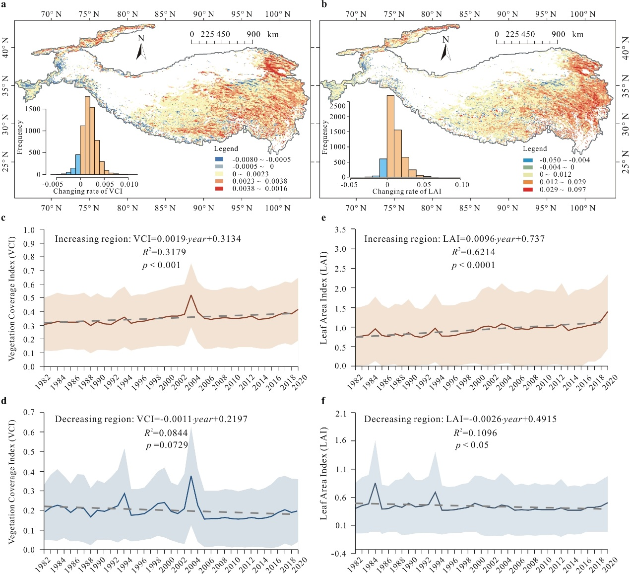

**Figure 1 | Changes in two vegetation cover indexes Vegetation Coverage Index (VCI) and Leaf Area Index (LAI).** **a,** The maximum VCI trend in the growing seasons during 1982-2020. The VCI data is calculated from the Advanced Very-High-Resolution-Radiometer (AVHRR) Normalized Difference Vegetation Index (NDVI) dataset (see Method 2). **b,** Growing season maximum AVHRR LAI trend during 1982-2020. The AVHRR LAI dataset is the average of three different products (GIMMS13, GLOBMAP23, and GLASS)41. **c,** **d,** Changes in the growing season maximum VCI over the increasing and decreasing regions of vegetation cover during 1982–2020. **e,** **f,** Changes in the growing season maximum LAI over the increasing and decreasing regions of vegetation cover during 1982–2020.

**Temperature response curves of vegetation cover.** To quantify the responses of vegetation cover to temperature, we created the temperature response curves of VCI and LAI in the Tibetan Plateau in Fig. 2 (see Methods 6). The specific results unveil significant findings that conflict with previously reported results; vegetation cover in both high-vegetated areas (VCI < 0.42 and LAI < 1.04) and low-vegetated areas (VCI > 0.55 and LAI > 1.54) is positively correlated with the corresponding temperature during the growing season (May to October). However, in the moderately vegetated area (0.42 < VCI < 0.55 and 1.04 < LAI < 1.54), vegetation cover is negatively correlated with the growing-season temperature. Based on the thresholds provided by the turning points of the vegetation–temperature curves, we identified the spatial area with vegetation negatively related to temperature, marked in yellow Figs. 2c and 2d. We see that the yellow areas are almost overlay the degrading vegetation areas depicted in Fig. 1. That is, the specific areas with degrading vegetation observed in the mid-vegetated areas in Fig. 1 are just a reflection of the negative response of vegetation to warming. Notably, in our recent field survey in the southeast of the Tibetan Plateau (May 13 to 20, 2021), we did observe extensive forest with sporadic dead birch (*Betula platyphylla* Suk.) in the mid-vegetated areas (Fig. S3). This phenomenon verified the degradating tendencies detected by remote sensing in Fig. 1 and the divergence problems revealed by temperature response curves in Fig. 2. This study first reported the degrading tendency and the divergence problems of vegetation in the moderately vegetated areas of the Tibetan Plateau. The detection and attribution of these phenomenon will offer insights into the consequences and mechanisms of climate change in terrestrial ecosystems, and aid planning and prioritization of the most vulnerable areas for protection and mitigation of change.

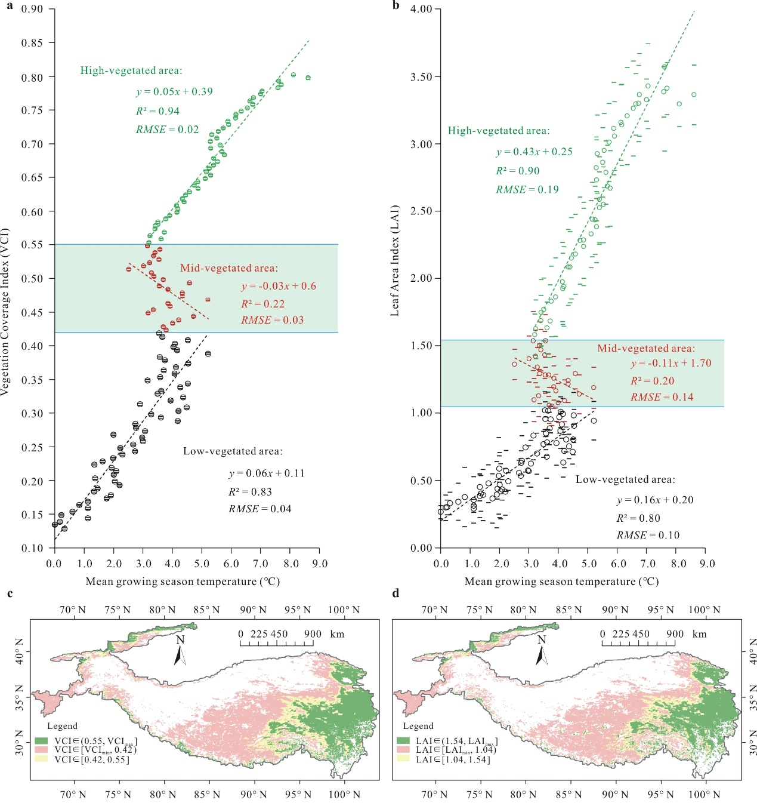

**Figure 2 | Temperature response curves of vegetation cover in Tibetan Plateau.** **a**, **b**, are temperature response curves of VCI and LAI, respectively. **c**, **d**, are the distribution areas of vegetation negatively related to temperature in Tibetan Plateau identified by the VCI and LAI thresholds recognized in **a** and **b**, respectively.

**Mechanisms.** To discern the mechanisms behind the observed divergence in vegetation response to warming in the moderately vegetated areas in the Tibetan Plateau, we established a structural equation meta-model to integrate key predictions on the impacts of water and energy on vegetation into a multi-process hypothesis for evaluation, as shown in Fig. 3a.

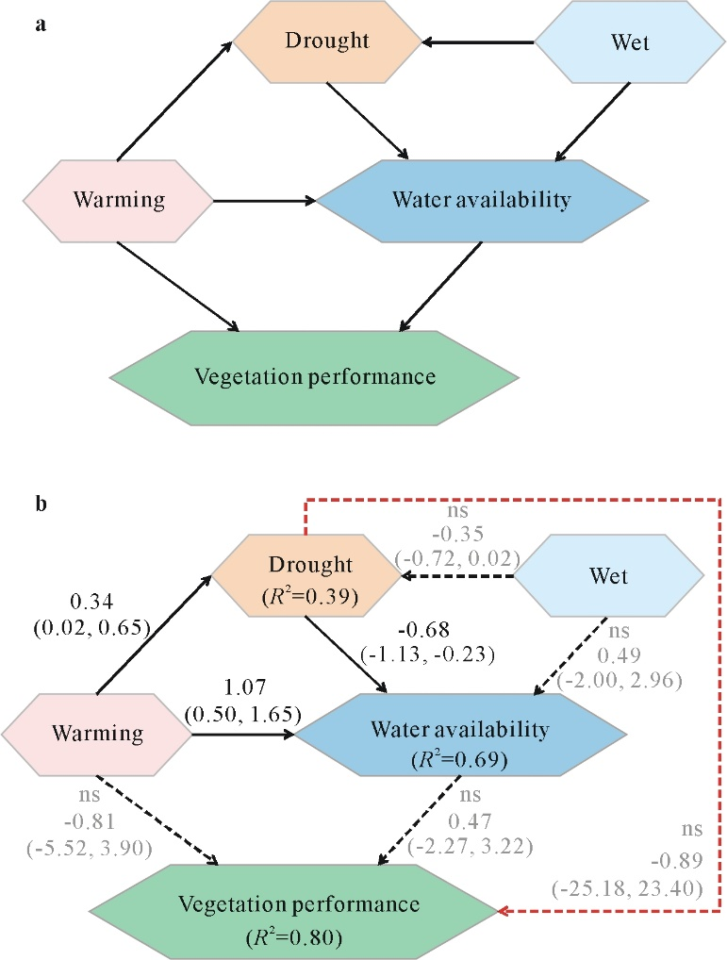

**Figure 3 | Structural equation models of the vegetation degrading areas in the Tibetan Plateau.** **a**, Structural equation meta-model. **b**, Structural equation model supported by the data. Solid arrows represent significant effects (95% credible interval does not contain 0), dashed arrows represent non-significant arrows (95% credible interval contains 0). The test statistic *MargLogLik*=-102. 02 and *BIC*=59.01, with 25 model degrees of freedom and *PP* = 0.45 (indicating close model-data fit).

This meta-model assumes that vegetation cover is controlled by the states of warming and water availability of ecosystems. Water availability is further determined by drought, reflecting water consumption of ecosystems via evapotranspiration, and the wet, reflecting the water input of ecosystems via precipitation. As evapotranspiration can be influenced by both warm and wet conditions, we also added linkages between warming to drought and wet to drought in the meta-model. As snowmelt is also an important water source for the Tibetan Plateau ecosystems, we also added the linkage from warming to water availability in the meta-data.

Synthesizing remote sensing and reanalysis data from multiple sources (Extended Table 1), we evaluated the meta-model in the vegetation degrading areas (see Method 3). Environmental variables included air temperature and soil surface temperature (constituting the model variable ‘Warming’), the dewpoint temperature and volumetric soil water (constituting the latent variable ‘Water availability’), the plant transpiration and soil evaporation (constituting the latent variable ‘Drought’), and the precipitation and snow depth water equivalent (constituting the latent variable ‘Wet’) (Extended Table 2, Fig. S4). The meta-model, along with the collected data, guided the development of a structural equation model for empirical evaluation. We evaluated model-data consistency to determine the presence of missing linkages in the initial model as well as to support the proposed links. We also assessed the dimensions of the model (i.e., the number of parameters and linkages) required to detect signals in the collected data. For this, we evaluated lower-dimensional versions of the model by removing linkages and re-evaluating against the data. Related data and methodological details are provided in the Methods and Supplementary Information.

Figure 3b is the structural equation model representing the connections between vegetation cover and other water and energy factors supported by the data in the vegetation-degrading area. First, we found clear evidence that warming increases drought (standardized path coefficient 0.34; 95% credible interval (CI) [0.02, 0.65]), which decreases water availability (coefficient −0.68; 95% CI [-1.13, -0.23]). Hence, warming has an indirect negative effect on water availability of ecosystems mediated by drought (coefficient -0.23). This finding is consistent with our hypothesis that negative vegetation–temperature relationship occurs due to increasing water consumption by evapotranspiration. However, surprisingly, the effects of both warming (coefficient -0.81, ns) and water availability (coefficient 0.47, ns) on vegetation cover in the moderately vegetated region are non-significant. This is because that both temperature and water availability are strong limiting factors of vegetation growth in this area, neither of them can have a significant impact on vegetation cover. That is, their interactions dominate the vegetation growth. Hence, our results demonstrate that failure to account for the variation in water availability explained by evapotranspiration would make it difficult to explain the negative influences of warming on vegetation.

We also found that the positive effect of wet variables on water availability is weak (coefficient0.49, ns), whereas that of the warming variable is strong (coefficient1.07; 95% CI [0.50, 1.65]). These findings suggest that snow melting is more important than precipitation for determining the water condition of ecosystems in this area. It also explains why the negative vegetation response to warming is limited to a small part of the Tibetan Plateau. The drying effect of warming on vegetation via increasing evapotranspiration can be partially offset in warmer climates due to an increase in the snowmelt. Besides, compared to the meta-model, the final model indicated a weak but direct inhibiting effect of drought on vegetation cover (coefficient -0.89, ns). It suggested that the drying ecosystem may limit vegetation growth in other underlying ways but they have not been included in the meta-model. We speculate that dry environmental conditions may affect vegetation growth by reducing the availability of soil nutrient conditions or microorganisms. Besides, other local factors such as elevation, permafrost thickness, soil characteristics, and climate regieme changes may also affect the responses of vegetation to warming. But the SEM conclusions drawn from the remote sening datasats of the whole plateau were difficult to elaborate these influences and their interactions. So, the influences of these local factors were not analyzed in this study. Additionally, the final model did not make any simplifications in the meta-model because it would fail to detect previously detected pathways and result in a dramatic loss of signal (as indicated by reduced values of *R*2 in the model).

**Discriminate condition of the negative response of vegetation to temperature.** Since the final SEM emphasized the importance of water availability via evapotranspiration, we further compared the relationship between vegetation cover and variables about water availability in the Tibetan Plateau, aiming to reveal the conditions which result in a negative response of the moderately vegetated areas to warming. As the vegetation cover has a clear decreasing pattern toward the northwest in Tibetan Plateau, we defined the southeast boundary of the decoupling response region (with vegetation cover states turning from high-vegetated to moderate-vegetated) as the upper boundary of the region, and the northwest boundary of the decoupling region (with vegetation cover state changing from middle-vegetated to low-vegetated) as the lower boundary. As shown in Fig. 4, the upper boundary is next to the saturation point of vegetation response to growing season precipitation (Fig. 4a) and almost consistent with the turning point of vegetation response to snow water equivalent in the growing season (Fig. 4b). This phenomenon can be interpreted as follows: when water is no longer a limiting factor of vegetation growth, the restraining effect of warming on vegetation, by increasing water consumption via evapotranspiration, would not work. In addition, Fig. 4c and 4d show that the lower boundary of the decoupling response of vegetation to temperature can be seen when the soil evaporation begins to decrease as vegetation cover increases. Because only in areas with certain vegetation cover will the soil evaporation decrease with an increase in vegetation cover, we reveal that the effect of warming on reducing water availability and inhibiting vegetation growth by increasing evapotranspiration can only work in areas with certain vegetation coverage but not in areas where soil evaporation is higher than vegetation transpiration in the growing season.

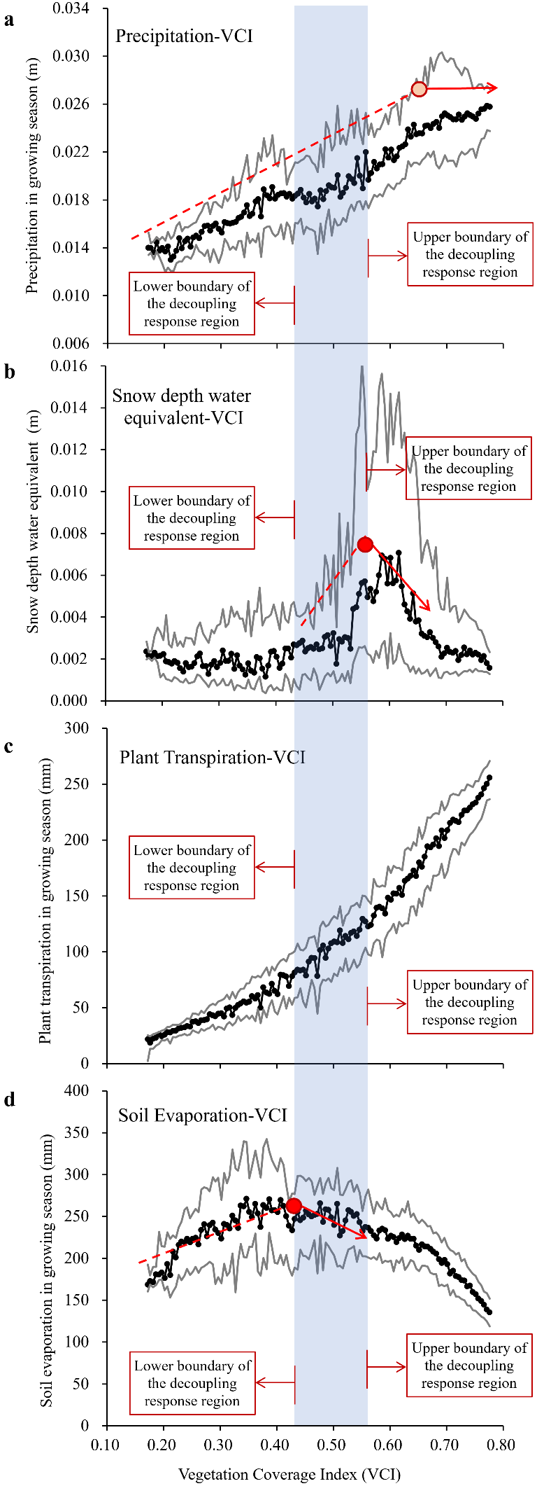

**Figure 4 | The corresponding relationship between the tipping points of VCI response to multiply water variables and the upper and lower boundaries of areas with vegetation negatively responding to warming. a**, Precipitation versus VCI. **b**, Snow depth water equivalent versus VCI. **c**, Plant transpiration versus VCI. **d**, Soil evaporation versus VCI.

Our studies revealed the existence of decoupling response of vegetation to warming in the alpine ecosystem of the Tibetan Plateau and identified its general spatial extent in this area at a 0.05° spatial resolution. The developed vegetation degrading maps can aid planning and prioritization of the most vulnerable areas for protection and mitigation of change in this area. An integrated SEM then discerned the mechanism of the decoupling problems and showed that due to the influence of evapotranspiration, the effect of temperature rise on vegetation growth becomes more complex than the positive correlation usually represented by the land surface model. These results revealed that current terrestrial ecosystem models may overestimate the impact of temperature rise on vegetation. They may also underestimate the decline in water resources during the growing season in the semi-arid regions via evapotranspirating. Besides, we detected the boundaries of the decoupling response of vegetation to temperature in Tibetan Plateau with multiple water availability-related environmental variables. The results revealed that the saturation point of vegetation response to water and the proportion of plant transpiration in the total ecosystem evapotranspiration may be the two boundaries’ conditions controlling the decoupling response of vegetation to warming. Although these specific thresholds may only be applicable to detect the decoupling areas in the alpine ecosystem in Tibetan Plateau at specific temporal and spatial resolutions. These findings emphasize the importance of eco-hydrological processes in mediating vegetation response to climate change and have an important reference for improving the current land surface model in predicting the vegetation changes in a warmer world.

**Methods**

**1. NDVI.** The NDVI is a vegetation index defined as the ratio of the difference between NIR and red visible reflectance to their sum, and is used to calculate the VCI in this study. Besides, to account for uncertainties from different satellite datasets and different indexes in the changing trend detection, we also checked the changing tendencis in three independent NDVI datasets in this study in Fig. S1, including bi-weekly NDVI data from Global Inventory Modeling and Mapping Studies (GIMMS) AVHRR, 16-day NDVI data from terra MODIS and 8-day NDVI Composite data from USGS Landsat TM/OLI products (Landsat 5, Landsat 7, and Landsat 8). The three NDVI datasets spanned three decades: 1982–2020 for AVHRR NDVI datasets, 2000–2020 for MODIS NDVI datasets and 1984–2020 for Landsat NDVI datasets, with the spatial resolutions of 8 km, 1 km, and 30 m, respectively. The average changing rate of the three NDVI products was also calculated and shown in Fig. S1d. Only positive NDVI values were used in the analysis.

**2. VCI.** An approach proposed for estimating fractional vegetation coverage by remote sensing, that is, the VCI, which can differentiate the green vegetation information and the bare soil information on a per-pixel basis. Following ref. Zhang et al. (2020), we calculated daily VCI for 1982–2020 using the daily AVHRR NDVI via the Equation of

, (1)

*,* where NDVIsoil is the NDVI value at the pure soil pixels, and NDVIveg is the NDVI value at the fully vegetated pixels. For the Tibetan Plateau, NDVIsoil was chosen to be the NDVI value in which the cumulative frequency is 0.5% in all pixels and NDVIveg was chosen to be the cumulative frequency of NDVI above 99.5%. The NDVI data were derived from the AVHRR NDVI with a spatial resolution of 0.05 degrees. Again, only positive VCI values were used in the analysis.

**3. LAI.** An approach proposed for measuring the number of layers of leaves by remote sensing. The LAI data were also derived from the NOAA CDR of AVHRR; only positive LAI values were used in the analysis.

**4. Climate dataset.** Meteorological data collected from multiple sources were used to evaluate the structural equation meta-model presented. The Extented Table 1 summarizes all the data used in this study and their sources. The meteorological data with different spatial and temporal resolutions were first resampled into the same spatial resolution of 0.05° and averaged in the growing and non-growing season during 2000–2020 (the overlapping time periods for all datasets). The vegetation data VCI and LAI were also averaged during 2000–2020 to match the timing of the climate data. The contour line of 3000 m in this area was taken as the boundary of the Tibetan Plateau area, which was then used to clip all the climate and vegetation maps used in this study.

**5. Structural equation model.** A structural equation model37 was developed based on the ideas embodied in the meta-model, available data, and the principles and procedures laid out in Grace et al.38. Indicators for constructs were chosen from the set of variables available and quantities that could be computed from them (Extended Table 2, Fig. S4). We fit the model in the R package ‘blavaan’ 39, initializing 3 MCMC chains that each took 25000 samples from the posterior distribution. We ensured that all the variables met the assumptions of normality and homoscedasticity. At each iteration, we estimated each of the *β* parameters and the indirect effect size and net effect size derived by combining path coefficients, discarding the first 5000 samples from each chain as burn-in. We assessed convergence on the target posterior distribution visually (Fig. S5) and by confirming that the Potential Scale Reduction Factor for each parameter40 was 1.001. We estimated the 95% credible interval around each parameter estimate, as well as an empirical *p*-value for each parameter, from the posterior samples. We compared the sizes of the effects of temperature and water etc. factors on vegetation cover by comparing standardized coefficients.

**6. Temperature response curve of vegetation cover.** By matching the maps of 2000-2020 averaged vegetation cover indexes (VCI and LAI) and the growing season air temperature pixel by pixel, we obtained the multiyear-averaged VCI-temperature and LAI-temperature record in each pixel. Then we generated VCI intervals with a step of 0.005 and use the intervals to divide the VCI- and LAI-temperature records into different groups. The averaged VCI, LAI, and temperature values and their standard deviations were calculated in each group, which were then plotted as the final temperature response curves of vegetation cover indexes.

**Data availability**

All data and R scripts necessary to reproduce the analyses in this manuscript are archived at <https://github.com/DaiXue-HHU/Tibet-Water-Energy-SEM>.

**Acknowledgment**

We would like to thank all the developers of the data sets mentioned in the Extended Table 1 for providing data. (基金信息有待添加)

**Author Contributions**

X.D. and Z.Y. conceived the study. X.D. prepared data, set up the model and conducted statistical inference, with all the authors providing input. Z.Y. further improved the analysis design. X.D. and Z.Y. led the manuscript writing and editing.

**Competing Interests statement**

The authors declare no competing interests.

**Supplementary Information**

Further supplementary information of this research is available in the *Nature Climate Change* summary linked to this article.

**References**

1. Berry, J. A. & Bjorkman, O. Photosynthetic response and adaptation to temperature in higher plants. *Annual Review of Plant Physiology*. **31**(1), 491-543 (2003). 10.1146/annurev.pp.31.060180.002423.
2. Kattge, J. & Knorr, W. Temperature acclimation in a biochemical model of photosynthesis: a reanalysis of data from 36 species. *Plant Cell Environ.* **30**(9), 1176–1190 (2007). [10.1111/j.1365-3040.2007.01690.x](https://doi.org/10.1111/j.1365-3040.2007.01690.x), Pubmed:[17661754](https://www.ncbi.nlm.nih.gov/pubmed/17661754)
3. Lloyd, J. & Farquhar, G. D. Effects of rising temperatures and [CO2] on the physiology of tropical forest trees. *Phil. Trans. R. Soc. B* **363**(1498), 1811–1817 (2008). [10.1098/rstb.2007.0032](https://doi.org/10.1098/rstb.2007.0032)
4. Medlyn, B. E. et al. Temperature response of parameters of a biochemically based model of photosynthesis. II. A review of experimental data. *Plant Cell Environ.* **25**(9), 1167–1179 (2002). [10.1046/j.1365-3040.2002.00891.x](https://doi.org/10.1046/j.1365-3040.2002.00891.x)
5. Piao, S. L. et al. Evidence for a weakening relationship between interannual temperature variability and northern vegetation activity. *Nat. Commun.* **5**, 5018 (2014). [10.1038/ncomms6018](https://doi.org/10.1038/ncomms6018), Pubmed:[25318638](https://www.ncbi.nlm.nih.gov/pubmed/25318638)
6. Huang, M. T. et al. Air temperature optima of vegetation productivity across global biomes. *Nat. Ecol. Evol.* 3(5), 772–779 (2019). [10.1038/s41559-019-0838-x](https://doi.org/10.1038/s41559-019-0838-x), Pubmed:[30858592](https://www.ncbi.nlm.nih.gov/pubmed/30858592)
7. Smith, N. G., Malyshev, S. L., Shevliakova, E., Kattge, J. & Dukes, J. S. Foliar temperature acclimation reduces simulated carbon sensitivity to climate. *Nat Clim. Change* **6**(4), 407–411 (2016). [10.1038/nclimate2878](https://doi.org/10.1038/nclimate2878)
8. Mercado, L. M. et al. Large sensitivity in land carbon storage due to geographical and temporal variation in the thermal response of photosynthetic capacity. *New Phytol.* **218**(4), 1462–1477 (2018). [10.1111/nph.15100](https://doi.org/10.1111/nph.15100), Pubmed:[29635689](https://www.ncbi.nlm.nih.gov/pubmed/29635689)
9. Myneni, R. B. et al. Increased plant growth in the northern high latitudes from 1981 to 1991. *Nature* 386(6626), 698–702 (1997). [10.1038/386698a0](https://doi.org/10.1038/386698a0)
10. Piao, S. et al. Characteristics, drivers and feedbacks of global greening. *Nat. Rev. Earth Environ.* **1**(1763), 1-14 (2019). 10.1038/s43017-019-0001-x
11. Wang, S. et al. Urban-rural gradients reveal joint control of elevated CO2 and temperature on extended photosynthetic seasons. *Nat. Ecol. Evol.* **3**(7), 1076-1085 (2019). [10.1038/s41559-019-0931-1](https://doi.org/10.1038/s41559-019-0931-1), Pubmed:[31235928](https://www.ncbi.nlm.nih.gov/pubmed/31235928)
12. Wang, S. et al. Recent global decline of CO2 fertilization effects on vegetation photosynthesis. *Science*. 370(6522), 1295-1300 (2020). 10.1126/science.abb7772
13. Chen, C. et al. China and India lead in greening of the world Through land-use management. *Nat. Sustain.* **2**, 122–129 (2019). [10.1038/s41893-019-0220-7](https://doi.org/10.1038/s41893-019-0220-7), Pubmed:[30778399](https://www.ncbi.nlm.nih.gov/pubmed/30778399)
14. Huntzinger, D. N. et al. Uncertainty in the response of terrestrial carbon sink to environmental drivers undermines carbon-climate feedback predictions. *Scientific Reports*. **7**(1), 4765 (2017). 10.1038/s41598-017-03818-2
15. Wang, X. et al. Field evidences for the positive effects of aerosols on tree growth. *Glob. Chang. Biol.* **24**(10), 4983–4992 (2018). [10.1111/gcb.14339](https://doi.org/10.1111/gcb.14339), Pubmed:[29855126](https://www.ncbi.nlm.nih.gov/pubmed/29855126)
16. Hansen, M. C. et al. High-Resolution Global Maps of 21st-Century Forest Cover Change. *Science* 342(6160), 850–853 (2013). [10.1126/science.1244693](https://doi.org/10.1126/science.1244693), Pubmed:[24233722](https://www.ncbi.nlm.nih.gov/pubmed/24233722)
17. Wolf, J. et al. Biogenic carbon fluxes from global agricultural production and consumption, *Global Biogeochemical Cycles*. **29**(10), 1617–1639 (2016). 10.1002/2015GB005119.
18. Parida, B. R. et al. Greening and browning trends of vegetation in India and their responses to climatic and non-climatic drivers. *Climate* **8**(8), 92 (2020). [10.3390/cli8080092](https://doi.org/10.3390/cli8080092)
19. Zhou, L. et al. Variations in northern vegetation activity inferred from satellite data of vegetation index during 1981 to 1999. *J. Geophys. Res.* 106(D17), 20069–20083 (2001). [10.1029/2000JD000115](https://doi.org/10.1029/2001389)
20. Kaufmann, R. K. et al. Reply to comment on “Variations in northern vegetation activity inferred from satellite data of vegetation index during 1981 to 1999” by J.R. Ahlbeck. *J. Geophys. Res. Atmos.* **106**, 20069–20083 (2001)
21. Loarie, S. R. et al. The velocity of climate change. *Nature* 462(7276), 1052–1055 (2009). [10.1038/nature08649](https://doi.org/10.1038/nature08649), Pubmed:[20033047](https://www.ncbi.nlm.nih.gov/pubmed/20033047)
22. Zhu, Z. et al. Greening of the Earth and its drivers. *Nature Clim. Change* 6(8), 791–795 (2016). [10.1038/nclimate3004](https://doi.org/10.1038/nclimate3004)
23. Tao, W. et al. Emerging negative impact of warming on summer carbon uptake in northern ecosystems. *Nat. Commun.* **9**(1) (2018). 10.1038/s41467-018-07813-7
24. Piao, S. L. et al. Weakening temperature control on the interannual variations of spring carbon uptake across northern lands. *Nature Clim. Change*. **7**(5), 359–363 (2017). 10.1038/nclimate3277
25. Liu, D. et al. Contrasting responses of grassland water and carbon exchanges to climate change between Tibetan Plateau and Inner Mongolia. *Agricultural and Forest Meteorology*. **249**, 163–175 (2018). 10.1016/j.agrformet.2017.11.034
26. D’Arrigo, R. D. et al. Thresholds for warming-induced growth decline at elevational tree line in the Yukon Territory, Canada. *Global Biogeochem. Cycles* **18**(3), GB3021, n/a–n/a (2004). [10.1029/2004GB002249](https://doi.org/10.1029/2004GB002249)
27. Sanders-DeMott, R. et al. Divergent carbon cycle response of forest and grass-dominated northern temperate ecosystems to record winter warming. *Glob. Chang. Biol.* **26**(3), 1519-1531 (2020 Mar). [10.1111/gcb.14850](https://doi.org/10.1111/gcb.14850), PMID: [31553818](http://www.ncbi.nlm.nih.gov/pubmed/31553818)
28. Duffy, K. A. et al. How close are we to the temperature tipping point of the terrestrial biosphere? *Sci. Adv.* **7**(3), eaay1052 (2021 Jan 13). [10.1126/sciadv.aay1052](https://doi.org/10.1126/sciadv.aay1052), PMID: [33523891](http://www.ncbi.nlm.nih.gov/pubmed/33523891), PMCID: [PMC7806211](https://www.ncbi.nlm.nih.gov/pmc/articles/PMC7806211)
29. Chen et al., 2020
30. Fu, Y. H. et al. Declining global warming effects on the phenology of spring leaf unfolding. *Nature* **526**(7571), 104-107 (2015). [10.1038/nature15402](https://doi.org/10.1038/nature15402), Pubmed:[26416746](https://www.ncbi.nlm.nih.gov/pubmed/26416746)
31. Zhao, Q. et al. Future greening of the Earth may not be as large as previously predicted. *Agric. Forest Meteorol.* **292-293** (2020). 10.1016/j.agrformet.2020.108111
32. Angert, A. et al. Drier summers cancel out the CO2 uptake enhancement induced by warmer springs. *Proc. Natl Acad. Sci. U. S. A.* **102**(31), 10823–10827 (2005). [10.1073/pnas.0501647102](https://doi.org/10.1073/pnas.0501647102), Pubmed:[16043702](https://www.ncbi.nlm.nih.gov/pubmed/16043702)
33. Beck, P. S. A. & Goetz, S. J. Satellite observations of high northern latitude vegetation productivity changes between 1982 and 2008: ecological variability and regional differences. *Environ. Res. Lett.* **6** (2011). 10.1088/1748-3182/6/4/[045501](http://www.ncbi.nlm.nih.gov/pubmed/045501)
34. Wu, Z. et al. Biogeochemical and ecological feedbacks in grassland responses to warming. *Nature Clim. Change* **2**(6), 458-461 (2012). [10.1038/nclimate1486](https://doi.org/10.1038/nclimate1486)
35. Liu, Y. et al. Plant hydraulics accentuates the effect of atmospheric moisture stress on transpiration. *Nat. Clim. Change* **10**(7), 691–695 (2020a). [10.1038/s41558-020-0781-5](https://doi.org/10.1038/s41558-020-0781-5)
36. Liu, L., et al. Soil moisture dominates dryness stress on ecosystem production globally. *Nat. Commun.* **11**(1), 4892 (2020b). [10.1038/s41467-020-18631-1](https://doi.org/10.1038/s41467-020-18631-1), [32994398](http://www.ncbi.nlm.nih.gov/pubmed/32994398)
37. Grace, J. B. & Bollen, K. A. Representing general theoretical concepts in structural equation models: the role of composite variables. Environ. Ecol. Stat. 15, 191–213 (2008).
38. Grace, J. B., Anderson, T. M., Olff, H. & Scheiner, S. M. On the specification of structural equation models for ecological systems. *Ecol. Monogr.* **80**(1), 67–87 (2010). 10.1890/09-0464.1
39. Merkle, E. & Rosseel, Y. *Blavaan: Bayesian Latent Variable Analysis*, 2016. -Version 0.2-3.121. *http://cran*, Available from: [r-project.org/package=blavaan](http://cran.r-project.org/package=blavaan)
40. Gelman, A. & Rubin, D. B. Inference from iterative simulation using multiple sequences. *Statist. Sci.* **7**(4), 457–472 (1992). [10.1214/ss/1177011136](https://doi.org/10.1214/ss/1177011136)
41. Xiao, Z. et al. Long-time-series global land surface satellite leaf area index product derived from MODIS and AVHRR surface reflectance. *IEEE Trans. Geosci. Remote Sensing*. **54**(9), 5301–5318 (2016). [10.1109/TGRS.2016.2560522](https://doi.org/10.1109/TGRS.2016.2560522)
42. Kong, D., Zhang, Y., Gu, X. & Wang, D. A robust method for reconstructing global MODIS EVI time series on the Google Earth Engine. *ISPRS Journal of Photogrammetry and Remote Sensing*. **155**, 13–24 (2019). [10.1016/j.isprsjprs.2019.06.014](https://doi.org/10.1016/j.isprsjprs.2019.06.014)
43. Zhang, Y. et al. Coupled estimation of 500m and 8-day resolution global evapotranspiration and gross primary production in 2002-2017. *Remote Sens. Environ*. **222**, 165-182, https://doi:10.1016/j.rse (2019). [10.1016/j.rse.2018.12.031](https://doi.org/10.1016/j.rse.2018.12.031)
44. Zhao, X. & NOAA CDR Program. NOAA Climate Data Record (CDR) of AVHRR Daily and Monthly Aerosol Optical Thickness (AOT) over Global Oceans, version 3.0. [indicate subset used] (NOAA National Centers for Environmental Information, 2017). [10.7289/V5BZ642P](https://doi.org/10.7289/v5bz642p) [date accessed]

**Extended Data**

**Extended Data Table 1 | Data sets, variables, and their sources**

|  |  |  |
| --- | --- | --- |
| Variables | Resolution | Sources |
| NDVI | 0.05°  Daily | AVHRR: The NOAA Climate Data Record (CDR) of AVHRR  (doi:10.7289/V5BZ642P) |
| LAI |
| Air temperature | 0.1 arc degrees  Monthly | ERA5: ERA5-Land monthly averaged data from 1981 to present  (DOI: 10.24381/cds.68d2bb30) |
| Soil surface temperature |
| RH |
| Soil moisture |
| Soil evaporation | 500 m  8-day | PML-V2: Penman-Monteith-Leuning Evapotranspiration in Google Earth Engine  (Kong et al.42) |
| Vegetation transpiration |
| Precipitation | 0.25 arc degrees | GLDAS-2: NASA Global Land Data Assimilation System Version 2 (DOI:[10.5067/E7TYRXPJKWOQ](https://doi.org/10.5067/e7tyrxpjkwoq)) |
| Snow cover | 0.1 arc degrees  Monthly | ERA5: ERA5-Land monthly averaged data from 1981 to present  (DOI: 10.24381/cds.68d2bb30) |
| Snow depth |
| Snow water |

**Extended Data Table 2 | Model variables and their indicators**

|  |  |
| --- | --- |
| Model Variables | Indicator Variables |
| Vegetation Cover | Function of VCI (unitless) and LAI (unitless) |
| Warming | Function of air temperature (℃) and soil temperature (℃) |
| Water availability | Function of volumetric soil water (m3/m3) and dewpoint temperature (℃) |
| Drought | Function of plant transpiration (m of water equivalent) and soil evaporation (m of water equivalent) |
| Wet | Function of precipitation (m), snow depth water equivalent (m of water equivalent), snow cover (%), and snow depth (m) |

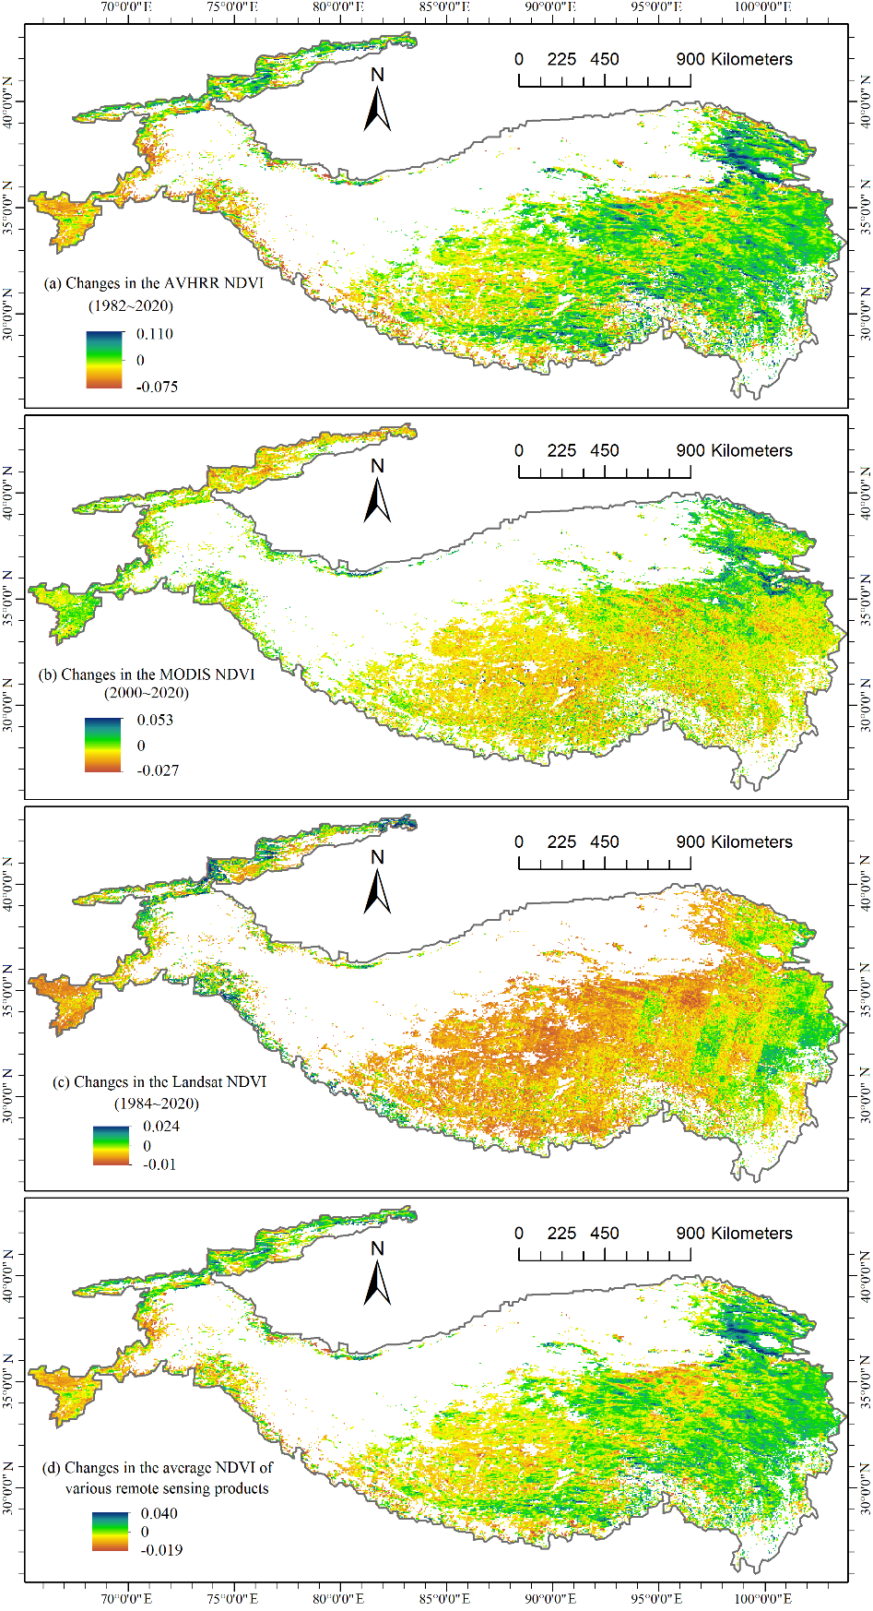

**Extended Data Fig. S1 | Changes of NDVI from different datasets in the alpine ecosystem of the Tibetan Plateau.** **a**, The 8-km bi-weekly NDVI data from Global Inventory Modeling and Mapping Studies (GIMMS) AVHRR during 1982–2020. **b**, The 1-km 16-day NDVI data from terra MODIS during 2000–2020. **c**, The 30-m 8-day NDVI data from USGS Landsat TM/OLI 8-Day NDVI Composite (Landsat 5, Landsat 7, and Landsat 8) during 1984–2020. **d**, The average changing rate of the three NDVI products.

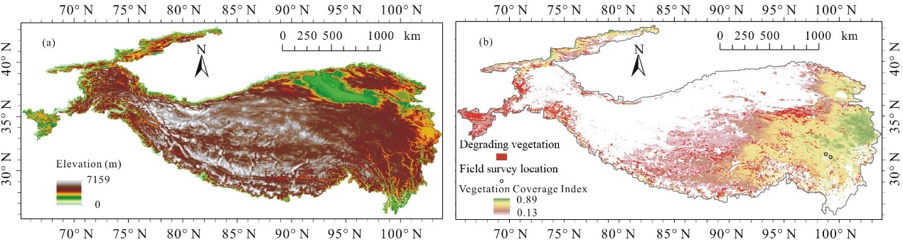

**Extended Data Fig. S2 | Basic topographical and vegetation conditions of the Tibetan Plateau. a**, The elevation gradients increasing towards northwest. **b**, the corresponding vegetation cover gradient (showing by the 1982-2020 average VCI) decreasing towards northwest in the Tibetan Plateau. The vegetation degrading areas were marked in **b**, as well as the locations with sporadic dead birch observed in the field survey.

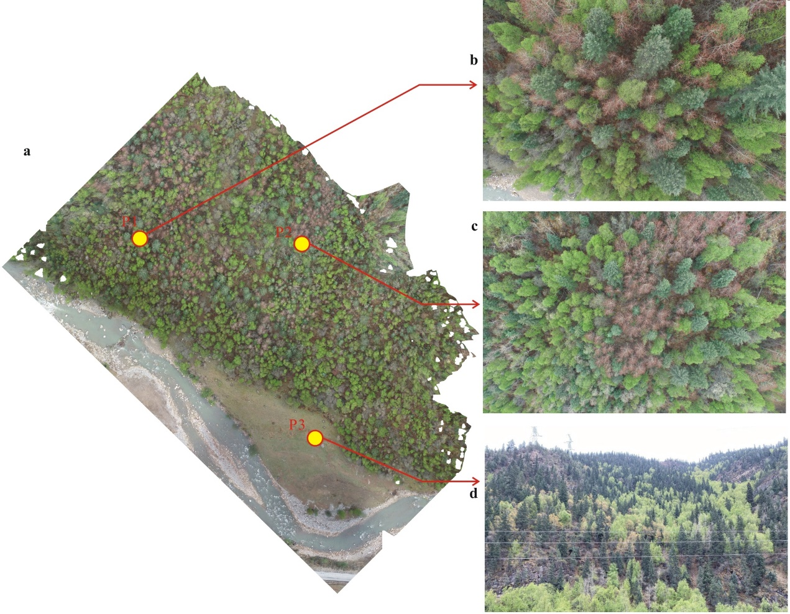

**Extended Data Fig. S3 | Observed extensive forest with sporadic dead birch (*Betula platyphylla* Suk.) in the field survey.** The location of the forest was marked in Fig. S2b. **a**, Reconstructed image of the hillside from 292 photoes taken by a unmanned aerial vehicle (UAV). **b**, **c**, vertical view from the UAV at the camera locations P1 and P2. **d**, horizontal view from the foot of the mountain at the camera location P3.

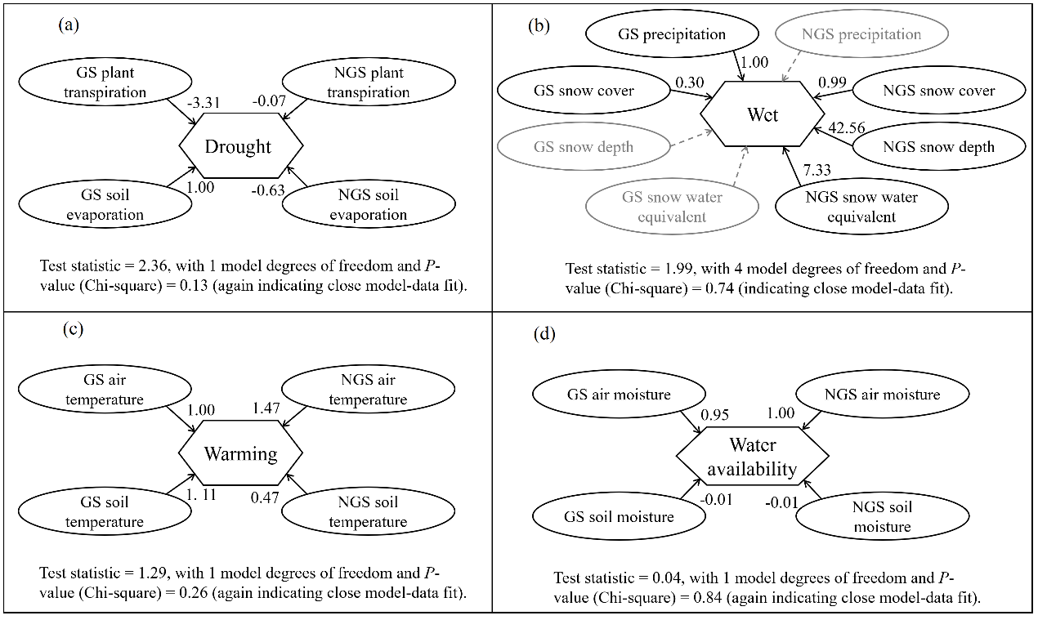

**Extended Data Fig. S4 | Construction of the model variables (i.e., latent variables of the SEM). a**, The latent variable Drought. **b**, The lantent variable Wet. **c**, The latent variable Warming. **d**, The latent variable Water availability.

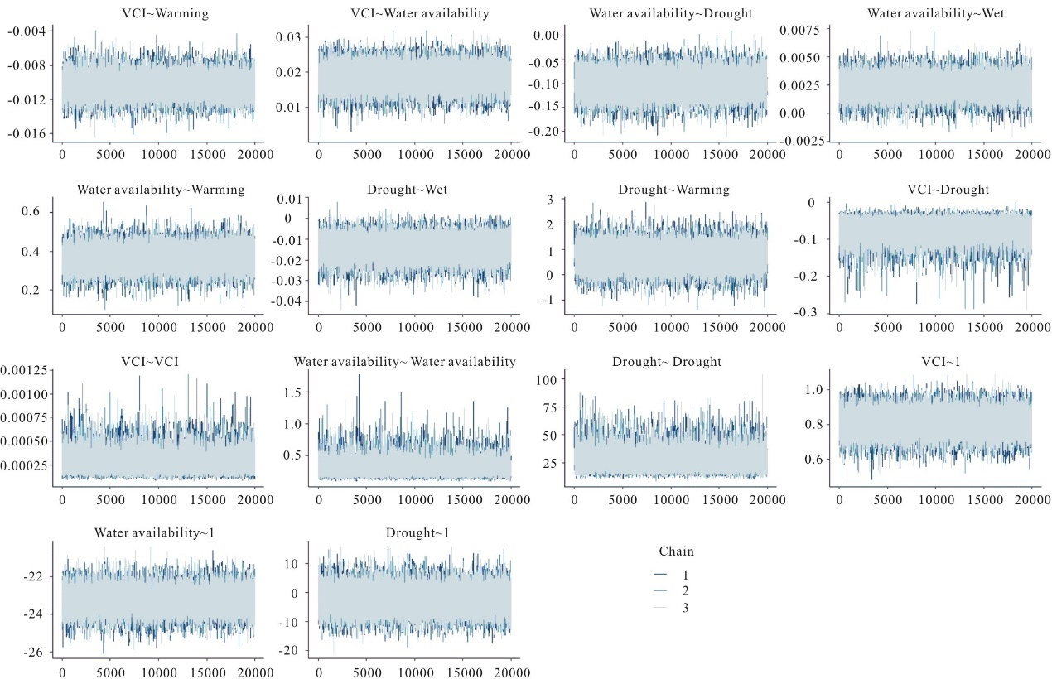

**Extended Data Fig. S5 | Convergence on the target posterior distribution of the SEM model.**